Sonia Sharman

Active since octobre 22 2020
4 videos posted
Every information available is in Morse code, except for the channel name.

We found the channel because an account posted it on an Amino channel. The account had been created only a day prior, October 21st
They seemed to have quite a lot of information, leading us to suspect they might be the owner of the Sonia Sharman channel

Identified individuals :
- Sonia Sharman (owner of the channel)
- Ratchel Harley (RH, cousin) (outed Sonia) 💀
- Lucy (Sonia’s gf) 💀
- Maycon (Accomplice)
- Maycon’s bully 💀
- Eleanore (Sonia’s friend, on the run)
- Maycon’s brother (asshole) 💀

Translation of the channel’s description :

I WANT THEM TO CATCH ME, FOR NOW THIS IS JUST A JOKE

1st video’s title : IHATEHR (I hate HR)

2nd video: I DIDNT WANT TO KILL HER, BUT
Description : I LOVED THAT GIRL, BUT SHE SAW WHAT I DID TO MY COUSIN. I CRIED SO MUCH AFTER I KILLED HER.

3rd video: MY REGRET IS THAT I KILLED MY GI (Girl ? gf ?)
Description :WE WERE PLANNING OUR WEDDING SOMETIME WHEN WE GOT OLDER, BUT THAT BITCH NAMED HARLEY HAD TO SHOW UP TO SCREW IT UP. I DONT REGRET KILLING HER

4th video : HAHAHAHAHAHA
Description : HALEY RATCHER5ALEY RATCHEL

5th video : IM GOING TO GO CRAY WITHOUT L
Description : I WANT HER, PLEASE BRING ME LUCY BACK I CANT I CANT BE WITHOUT HER SHES EVERYTHING BUT I DONT WANT HER TO BE AFRAID OF ME SHE WAS AFRAID OF ME I NEED MY LUCY LUCY LUCY LUCY LUCY LUCY LUCY LUCY LUCY LUCY LUCY LUCY LUCY LUCY LUCY LUCY LUCY LUCY LUCY LUCY LUCY LUCY LUCY LUCY LUCY LUCY LUCY LUCY LUCY LUCY LUCY LUCY LUCY LUCY LUCY LUCY LUCY LUCY LUCY LUCY LUCY LUCY LUCY LUCY LUCY LUCY LUCY

5th video : I LIED
Description : I DONT KNOW HOW TO DRIVE. MAYCON HELPED ME. IT HELPS ME WITH A LOT OF THINGS

6th video : ARRUMANDO MINHAS COISAS PARA E (portuguese – translation : Packing up my things for – google translate so mistakes possible)
Description : MAYCON WILL TAKE ME TO ANOTHER CITY. I WILL LIVE ALONE. THE POLICE ARE LOOKING FOR LUCY BUT NO ONE HAS MISSED HARLEY YET. FROM TOMORROW I WILL RECORD MY

Comment under 3rd video :

SHE WAS SUCH A SWEET GIRL. I WOULD MAKE ALL THE SACRIFICES FOR HER. BUT I DIDNT WANT HER TO BE AFRAID OF ME. NOW SHE IS IN HEAVEN, AND I AM HERE CRYING TO SEE HER BODY UNDER MY BED. WHY IS NO ONE LOOKING FOR HER?

Sonia seems to regret having killed Lucy, her gf, seeing as it has left her crying. She does not seem to regret killing HR, her cousin, though.

Answer to a comment I posted asking her why she killed HR :
THAT BITCH TOLD MY SEXUALITY TO THE WHOLE SCHOOL

The amino user really is suspect and seems to know way too much.

RATCHER5ALEY : Unknown meaning.

But, why woyld a 5 be in the middle of a sentence ? Especially since as of now, this is the only time a number has appeared. Maybe something to do with a fifth video coming out ?

Answer to me asking if she was alright in the comments :
I HAVE BEEN FEELING DEPRESSED SINCE THE MURDER OF MY LUCY. NO ONE DESERVED HEAVEN MORE THAN SHE DID. BEFORE I WANTED HER TO BE SAFE, BUT I NEVER IMAGINED SHE WOULD BE AS SAFE AS SHE IS NOW, IN THE CLOUDS
02:01
Sonia is 14 years old.

I aked her how was Lucy when she was alive :
@Juliette Debackere SHE WAS AN INCREDIBLE GIRL. SHE HELPED ME SO MUCH. WE MET AT AN ANIME EVENT. I HAD TO KILL HER AFTER SHE SAW ME KILLING RATCHEL. SHE WAS SO SCARED. EVERY DAY I HAVE NIGHTMARES WITH YOUR SCREAMS BUT WAKING UP AT DAWN AND LOOKING AT YOUR FACE MAKES ME MORE COMFORTABLE
02:18
Manic phase ? Confusion, she’s directly adressing me then start using “your face” as if she was talking to Lucy.

@Abdon Kodda SHE WAS JEALOUS OF ME BECAUSE I GOT BETTER GRADES AND GOT MORE ATTENTION FROM MY PARENTS THAN SHE DID. SHE HAS BEEN TORMENTING ME EVER SINCE AND WHEN SHE FOUND OUT ABOUT MY GIRLFRIEND SHE TOLD THE WHOLE SCHOOL. WHEN I ARRIVED AT SCHOOL EVERYONE CALLED ME ABSURD THINGS. AT THE END OF CLASS WHILE I WAS GOING TO LUCYS HOUSE SHE CAME TO PISS ME OFF. SO I KILLED HER BUT LUCY HEARD ME SCREAMING AND WHEN SHE SAW WHAT I DID I HAD TO KILL HER
02:42

Complete backstory :

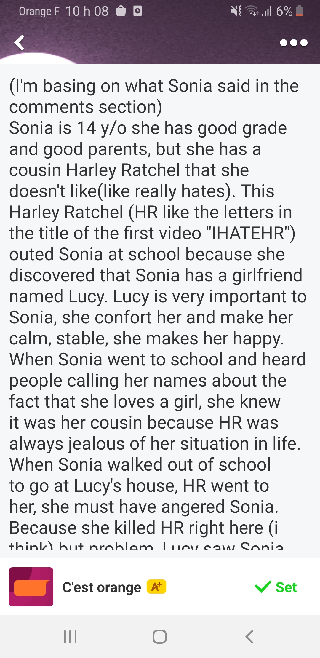
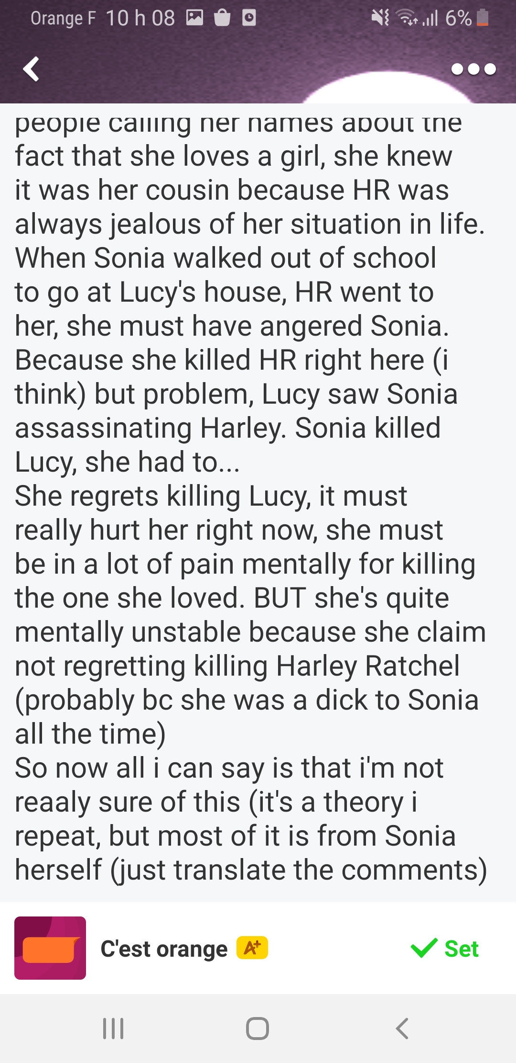

Random comment answer :
@Abdon Kodda I DONT CARE ABOUT ANSWERING QUESTIONS, I LIKE IT BECAUSE I FEEL LIKE I HAVE FRIENDS. I SET HER CAR ON FIRE WITH HER BODY IN IT, I DROVE INTO THE MIDDLE OF NOWHERE AND CRASHED 3 TIMES LOL I WOULD GIVE ANYTHING TO SEE HER CAR BURNING AGAIN, THE SMELL WAS REALLY WEIRD

We now know how she got rid of HR’s body.

I DIDNT GET HURT TOO MUCH, BECAUSE I HAD ALREADY DRIVEN WITH MY FATHER BEFORE, HE TAUGHT ME. SINCE THE JUNE VACATION IS ABOUT TO START AND THERE WILL BE NO ONE AT HOME BUT ME, NO ONE WILL MISS HR BECAUSE SHE CAME TO SPEND THE HOLIDAYS WITH ME ÐBUT I DIDNT WANT TOÐT
16:59

June ? We are not in June.

@Juliette Debackere NO, ITS JUNE, THE HOLIDAYS HAVE JUST STARTED
18:25

Reaffirms her belief

@Juliette Debackere OF COURSE. ITS 159 PM, JUNE 4TH
19:04

Idib

I LIED BECAUSE I WANTED TO LOOK COOL. MAYCON IS A FRIEND OF MINE. HE DROVE WITH ME TO THE MIDDLE OF NOWHERE TO BURN HARLEYS CORPSE. THE CAR WAS NOT BURNED, I LIED ABOUT IT TOO

We learn of Macon’s existence in this video, he is helping Sonia.

Morse code appearing in video 6 :
MAYCON AND I DECIDL THAT WE WILL KILL EVERYONE WHO BULLIED ME

Weird voices can be heard in the background of video 6.
Impossible to translate, maybe in a language we can’t identify.

Conversation I had with Sonia and what we have to say about it :

As we talk, she confirms that she and Maycon are going to go on the run. Maycon is one of her friend, 16 years old so older than her. He is helpinf her because she apparently killed his bully ? Sonia is not sure how many people she had killed because her brain tends to dissociate to protect her. She estimates the number to be around 4. Sonia is evidently mentally ill. She had dissociated two years of her life and is persuaded to be living in 2018. The reason she has this delusion seems to be because she claim to have done a ritual found in an obscure book meant to send her back in time, this was done to prevent Lucy from dying, which was, evidently, impossible. She still can’t believe we are in 2020 no matter how much I try to make her see sense. It also appeared that she was drugged, with pills, which furthered her delusions. Maycon is not delusioned though, and knows we are in 2020, as he told me himself. They then left to go on the run and I haven’t gotten any news since.

